**Corona Tweet Classification System**

**PROJECT REPORT**

*in partial fulfilment for the award of the degree*

*of*

**BACHELOR IN COMPUTER APPLICATIONS (B.C.A.)**



PROJECT GUIDE: SUBMITTED BY:

**Ms. Shreya Agrawal Ahmad Faraz Ansari**

**Enrollment No.: U1946007**

**Date Of Submission: 27-04-2022**

**CENTER OF COMPUTER EDUCATION**

**Institute of Professional Studies, University of Allahabad**

**2019 – 2022**

Table of Contents

* Certificate
* Acknowledgement
* Declaration
* Introduction
* Proposed System
* Coding
* Testing and Deployment
* Challenges and Future Scope
* Conclusion
* Bibliography

CERTIFICATE

This is to certify that **Ahmad Faraz Ansari** of **Centre of Computer Education, Institute of Professional Studies, University of Allahabad, Prayagraj** has successfully completed his project on the topic **Corona Tweet Classification System** under the guidance of **Ms. Shreya Agrawal** during the academic year 2019 - 22 as per guidelines given by **University of Allahabad, Prayagraj**.

**Ms. Shreya Agrawal Dr. Ashish Khare**

**Guide Course Coordinator**

ACKNOWLEDGEMENT

Project is an important milestone in the completion of any Professional Course. As a student of B.C.A, I got the golden opportunity to do this work.

It gives me immense pleasure to express my feelings of deep gratitude towards the subjects without whom, it would have been very difficult to accomplish this mammoth project.

I wish to express my thank to my parents, my supervisor **Ms. Shreya Agrawal** as well as **Dr. Ashish Khare (Course Coordinator),** who provided me this golden opportunity to work on this wonderful project called “**Corona Tweet Classification System”,** which also helped me in doing lot of research, which, in return, gave me insight on so many new things are going to help me in the foreseeable future.

I would like to thank all those who have helped me in providing direction, information and advice at all stages in this Project.

I take this opportunity to thank the **University of Allahabad** for giving me chance to do this project.

DECLARATION

I, **Ahmad Faraz Ansari**, hereby declare that the project report entitled “**Corona Tweet Classification System**” has been submitted to **University of Allahabad** in partial fulfilment of the requirement for the award of degree of B.C.A., is a record of Bonafede Project work carried out by me, under the guidance of **Ms. Shreya Agrawal**.

I further declare that this project has not been submitted and will not be submitted, either in part or full, for the award of any other degree or diploma in this institute or any other institute or university.

The work contained in the report is original and has been done by me under the general supervision of my supervisor.

I have followed the guidelines provided by the University of Allahabad in writing this report.

**Date: 27-04-2022 AHMAD FARAZ ANSARI**

**Place: Allahabad B.C.A. -6th Semester**

INTRODUCTION

Corona Tweet Classification System or also known as Covid Tweet Classification System, is a Machine-learning based tweet classification system.

It is developed entirely using Python 3 for platform-independency.

Classification is done using SVM algorithm.

Proposed System can classify tweets based on the underlying emotion i.e., whether tweet is covid-positive or covid-negative.

The main objective of this project includes:

* Creating a system that can classify tweets using machine-learning.
* Classification of tweets is to be done on the basis of severeness of the underlying emotion.

PROPOSED SYSTEM

The Primary Reason for the existence of the Corona Tweet Classification System is the problem associated with online casino games.

They are very time, resource consuming and very expensive. Corona Tweet Classification System, on the other hand, is made to deliver best user-experience possible in lesser time and resources.

It is simpler, more enjoyable and less-resource/time consuming than other games available in the same genre. It is very quick, responsive and user-friendly.

The proposed Corona Tweet Classification System will take on off-line casinos and other games associated with BlackJack. It will take care of all the Player resources without requiring any Player Interaction. Player is not supposed to get into the details of underlying software technicalities and its model (abstraction).

Machine Learning Pipeline Diagram

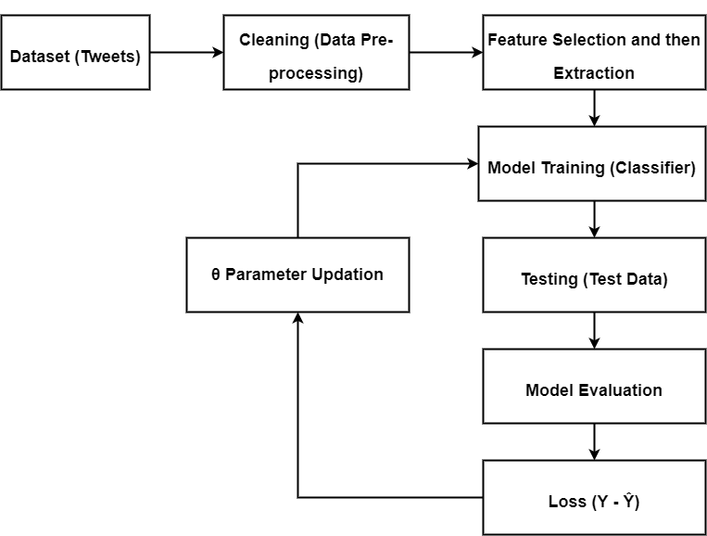

Flow Chart of Corona Tweet Classification System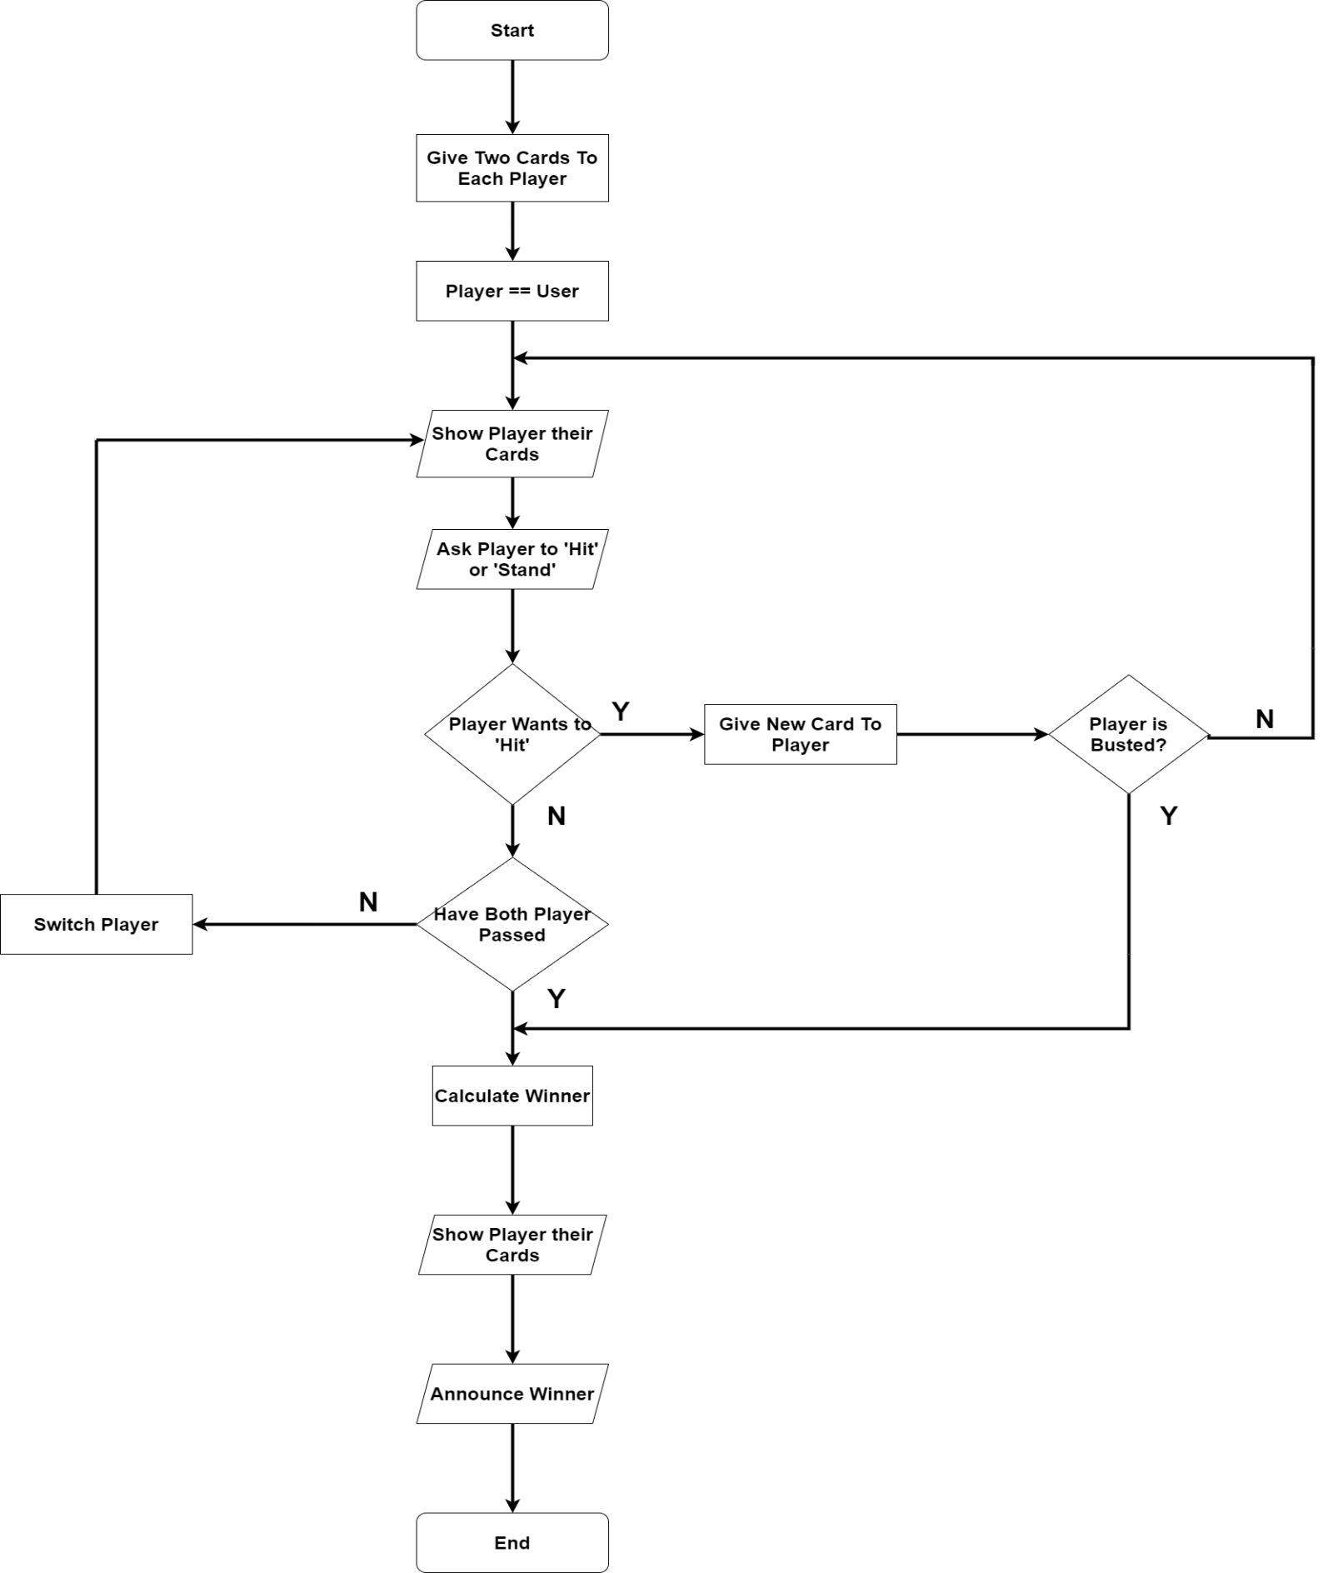

SNAPSHOTS of PROJECT (GUI)

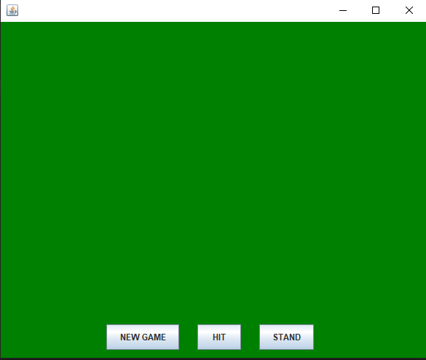Home Screen

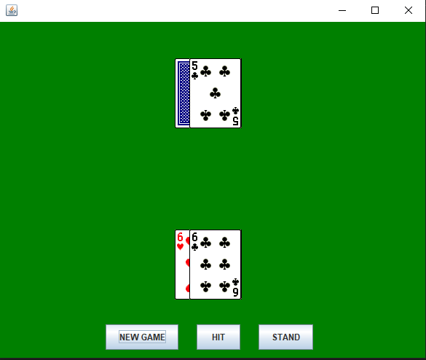

Active Game Screen

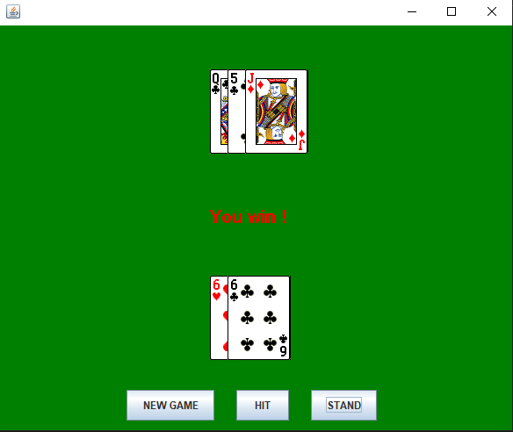 Win screen 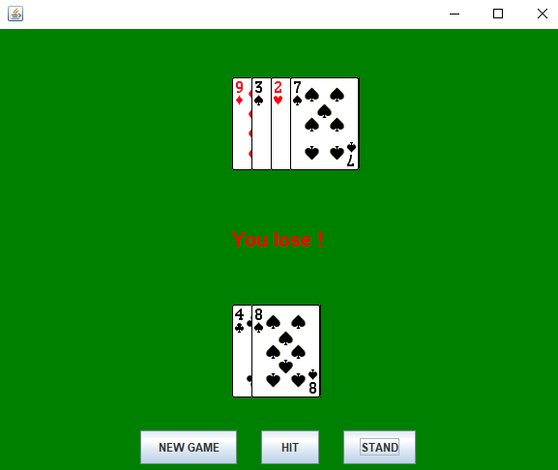Lose Screen

CODING

BlackJackGUI.java

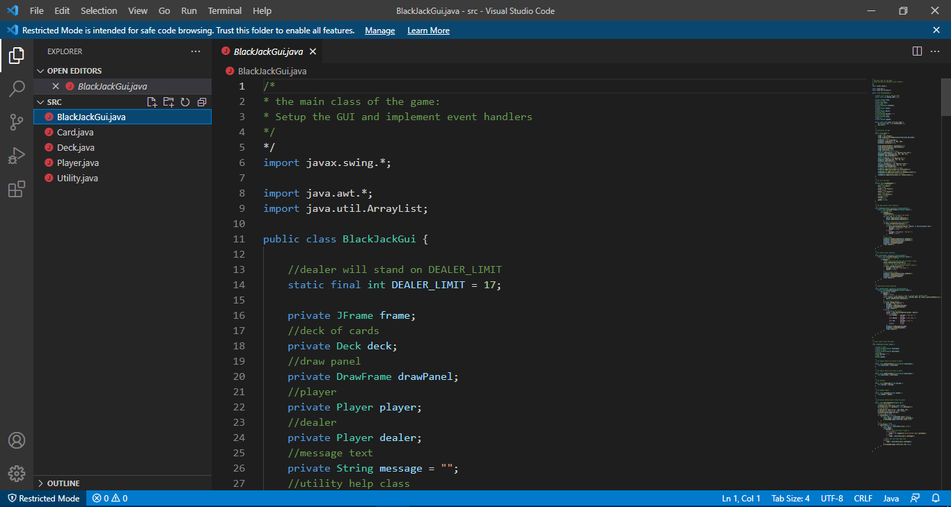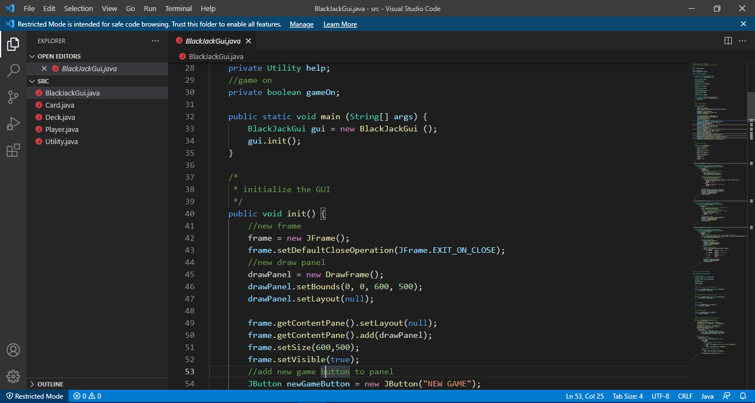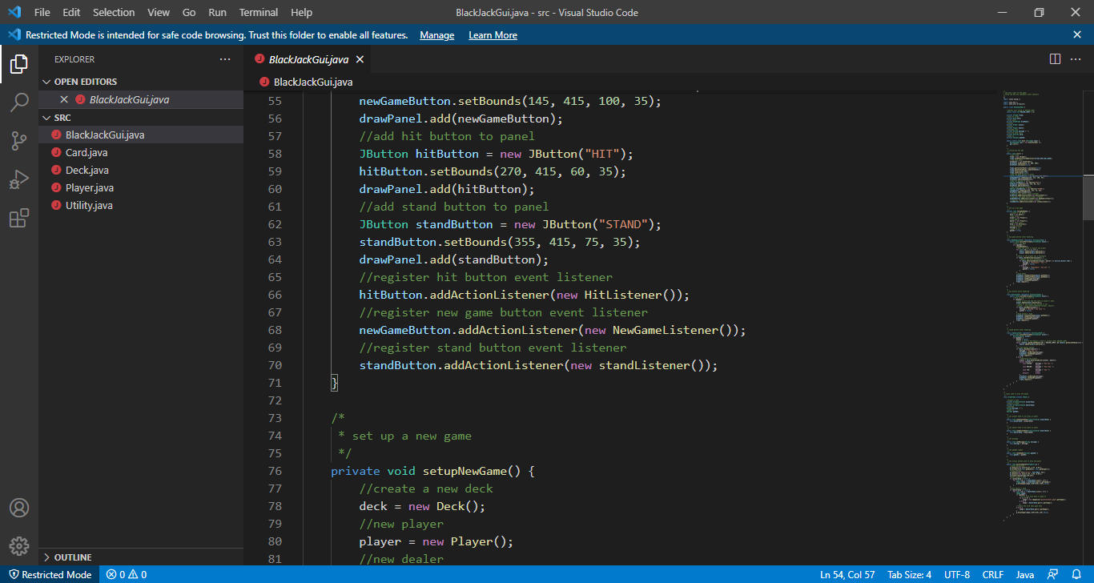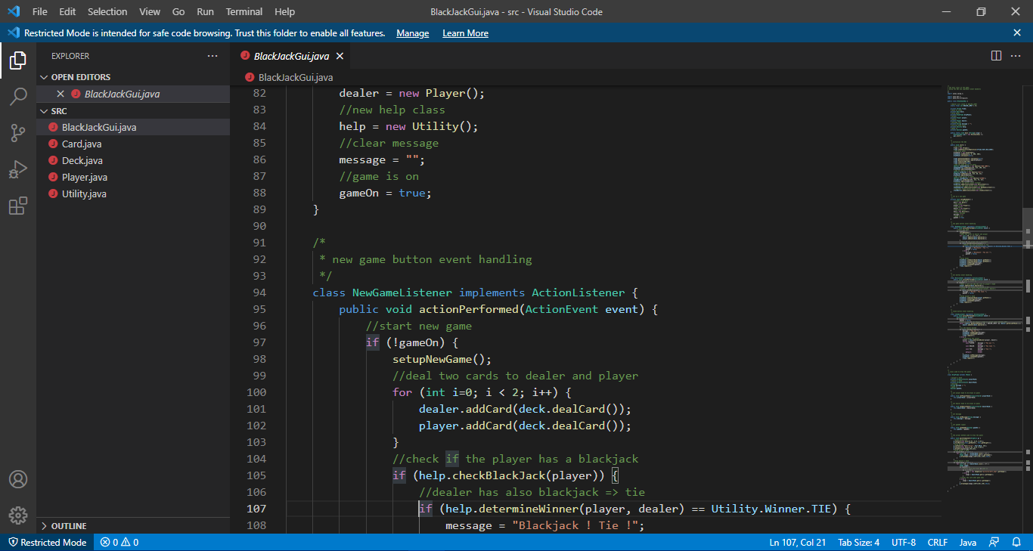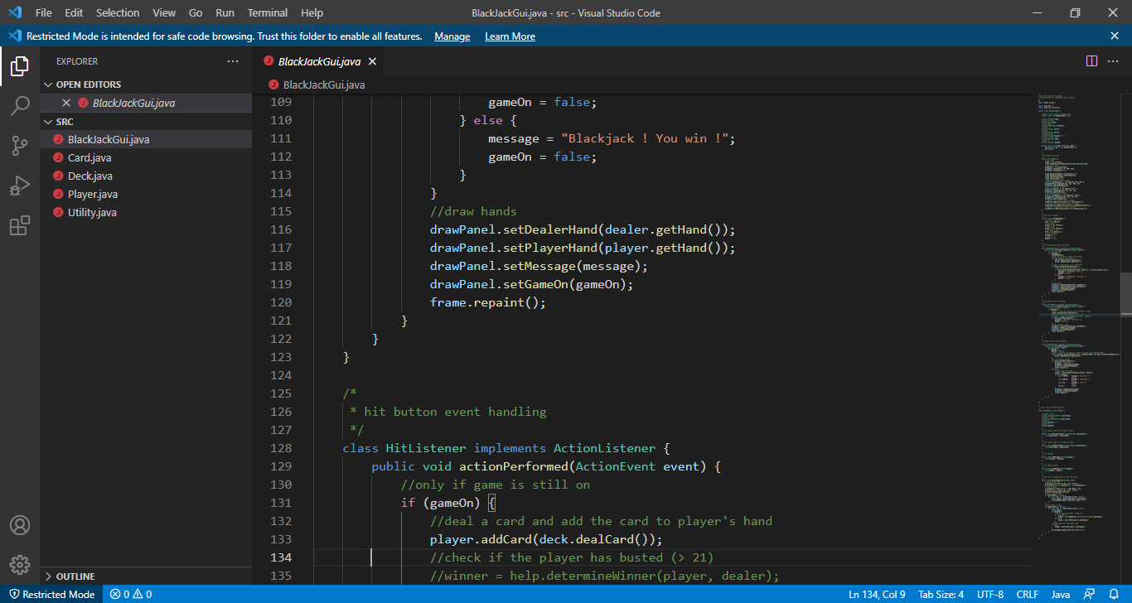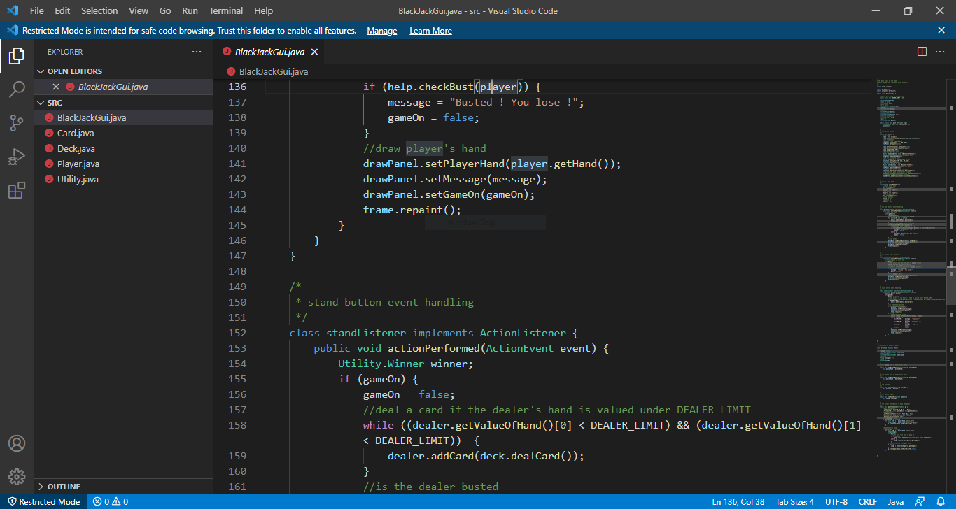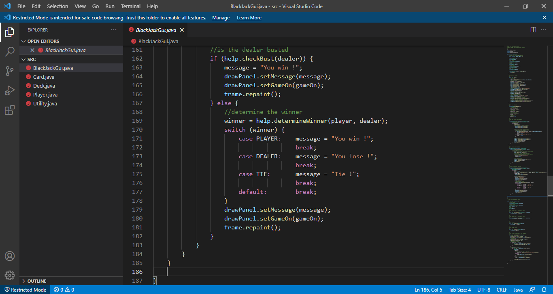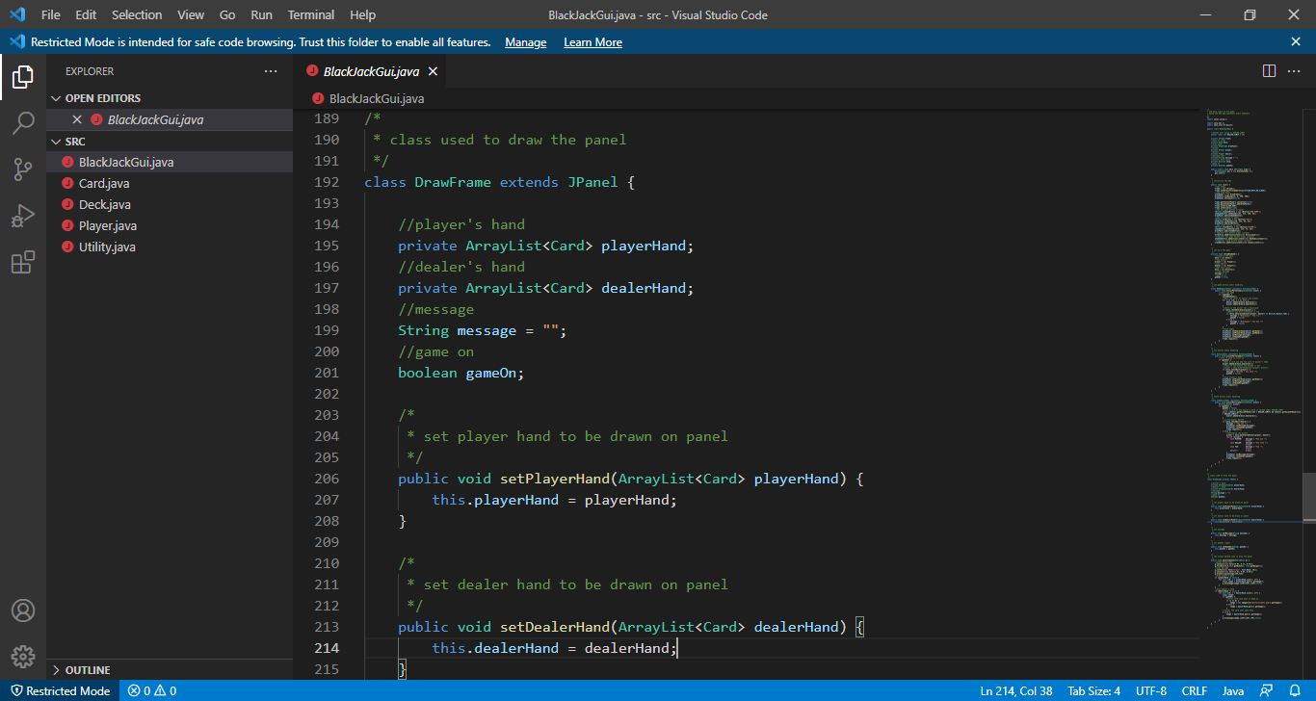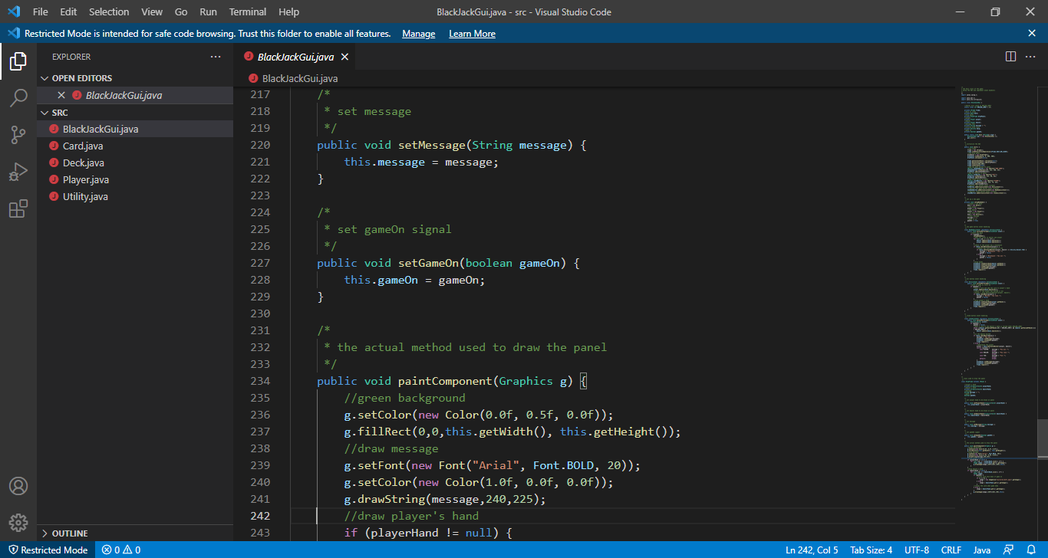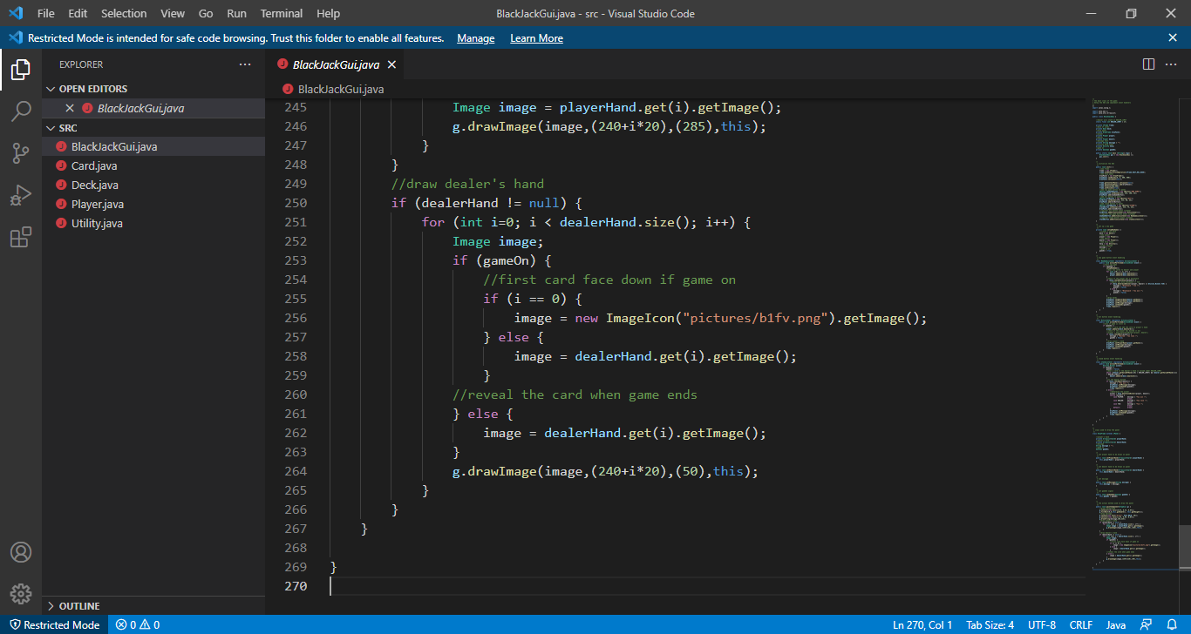

Card.java

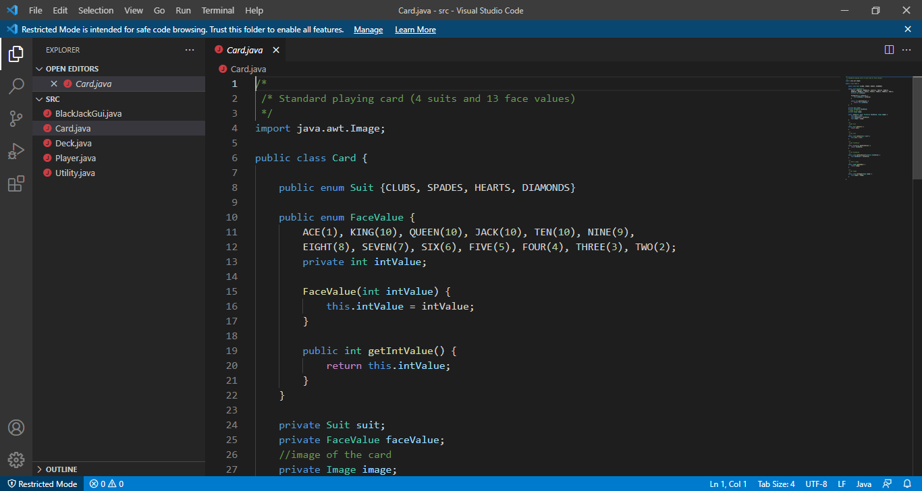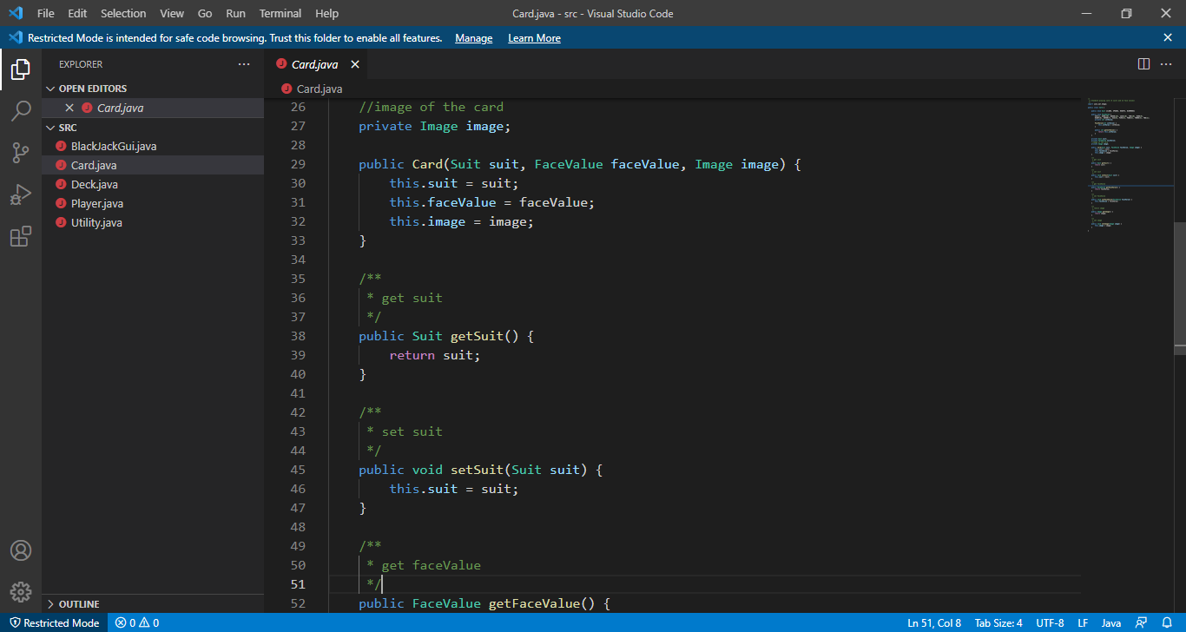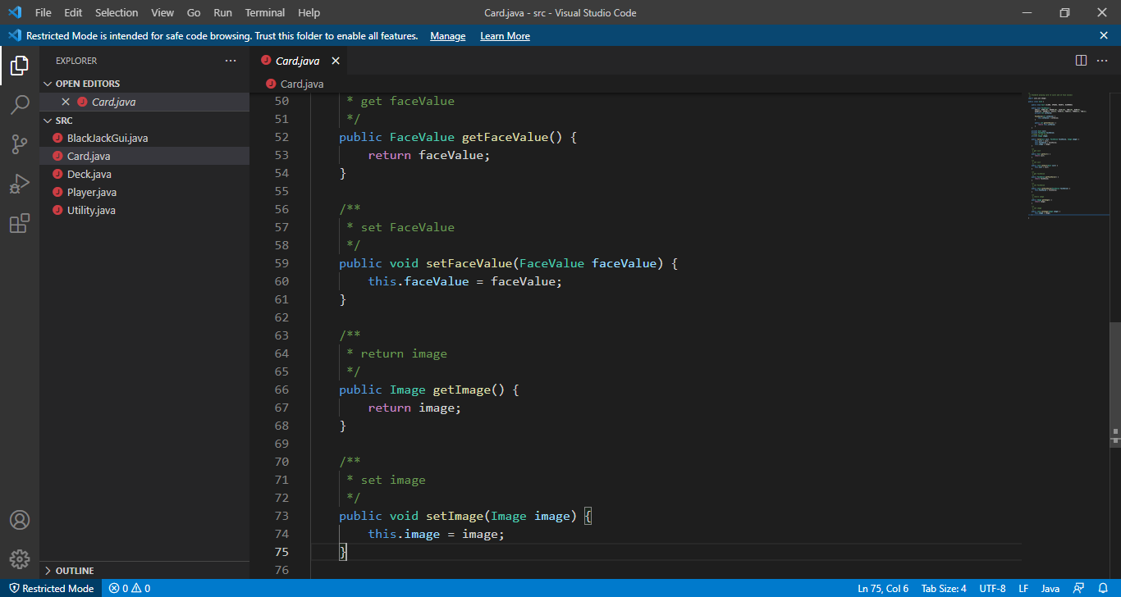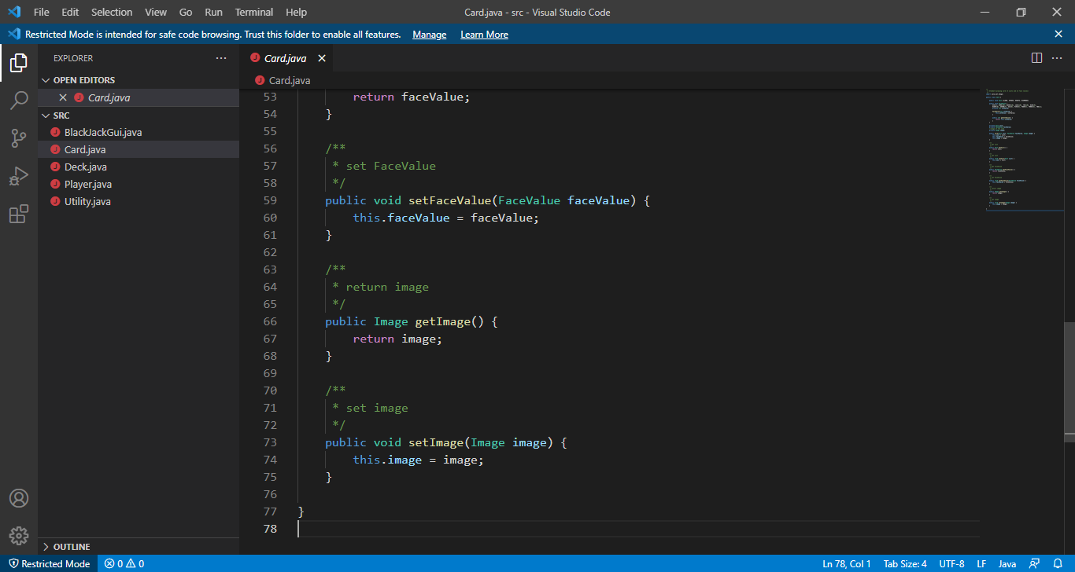

Deck.java

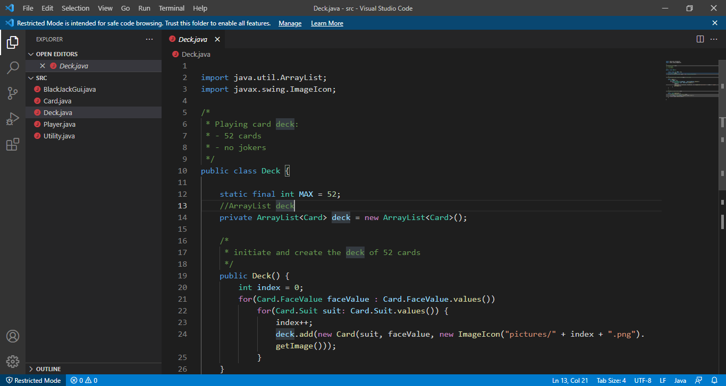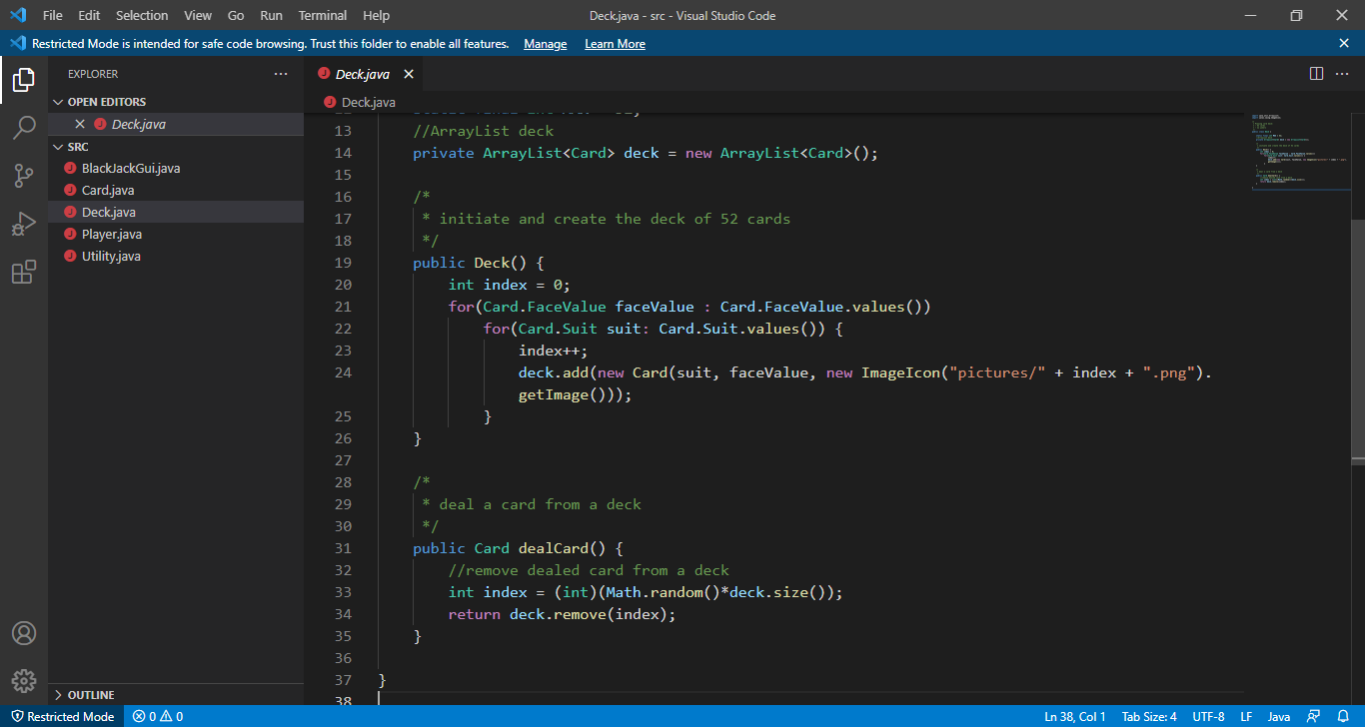

Player.java

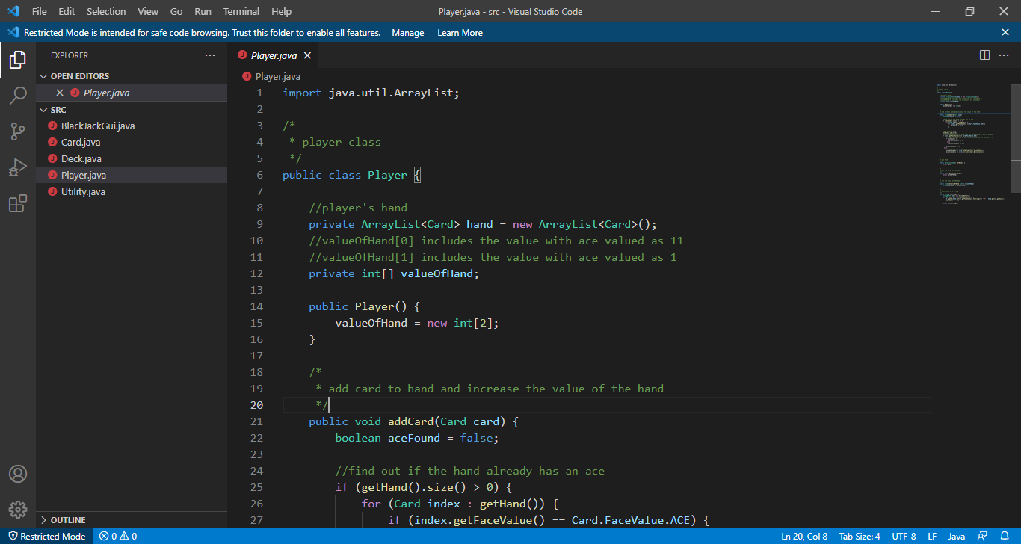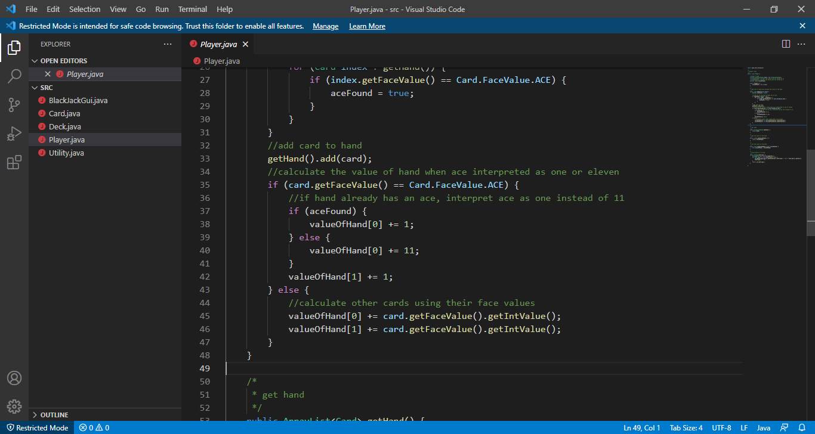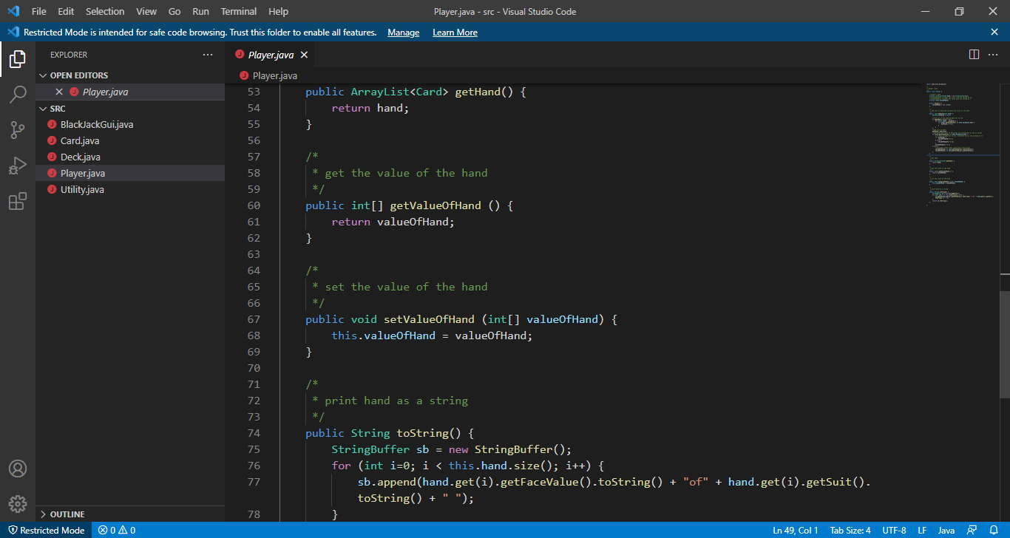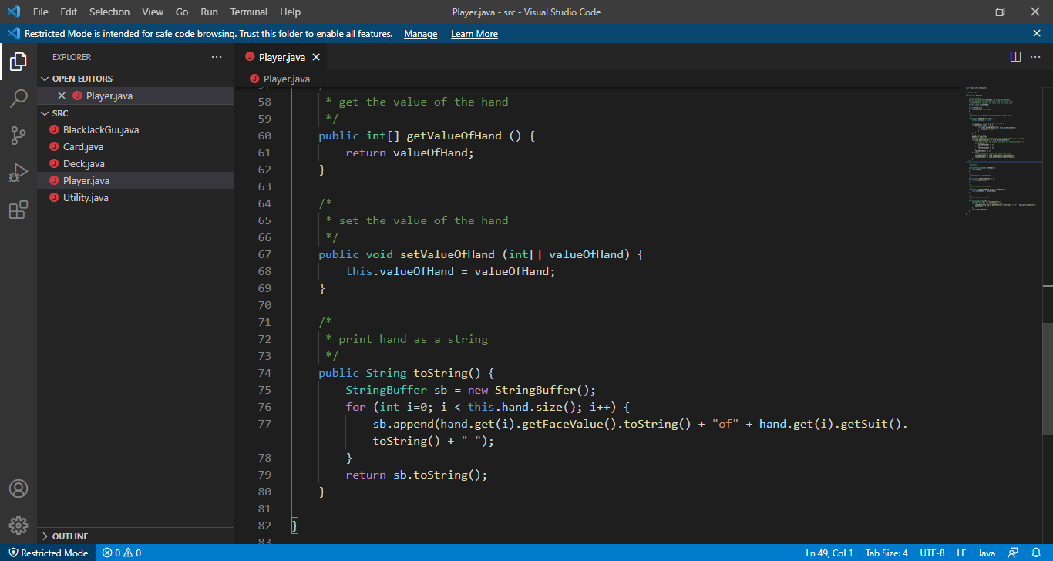

Utility.java

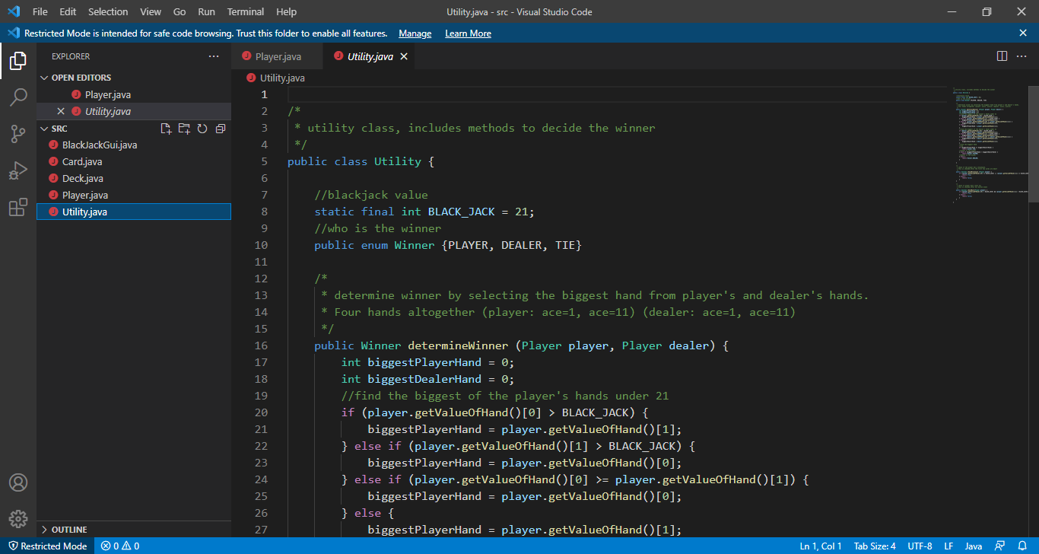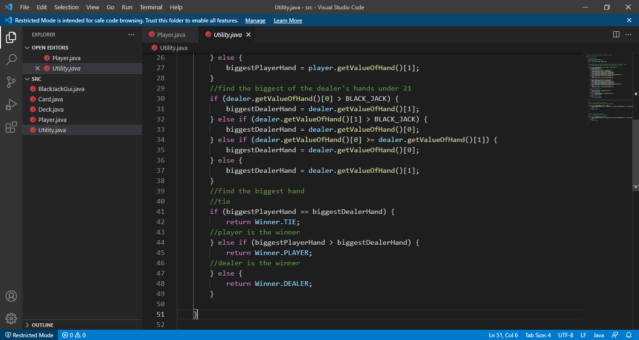

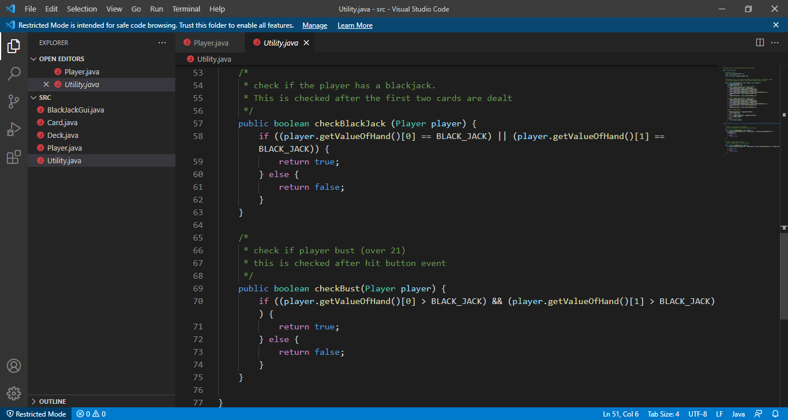

TESTING AND DEPLOYEMENT

Software Testing is a Process of executing a program with the intent of finding errors during the run-time of program. It a feasible task to try and find the errors (whose presence is assumed) in a program, as it is a destructive process.

I have tried to understand the proposed system by detailed study of the various operations that will be performed by a system.

System analysis is the process of studying an existing system to determine how it works and how it meets user needs. System analysis lays the groundwork for improvements to the system. The analysis involves an investigation, which is turn usually involves establishing a relationship with the client (Player), for whom the analysis is done, and with the user of the system. This analysis phase is more of a thinking process. In this phase, I have improved logical aspects of the system.

To develop the system, one must deal with errors, bugs, defects etc. in more seamless way than ever, in order to preserve the integrity of Project and also to maintain the flow of maintenance.

I did thorough examination of the system processes, gathering Operational data, understanding the information flow, finding out weaknesses and evolving solutions for overcoming the weaknesses of the system so as to achieve the goals.

During the analysis phase, I dealt with:

* Data Gathering
* Data Analysis

Gathering the data for the completion of the Project was hard and also expensive, given the complexity of the Project. Once the gathering was done, Analysis phase was started, leading to thorough examination of the Project to make less prone to bugs, errors, defects etc.

CHALLENGES AND FUTURE SCOPES

*“There is always room for improvements”*

There are lot of things that can be added to the Project in future to make it more dynamic with respect to time.

Following are the abilities that can be added to the Project to make more modern and fun and also visually – appealing.

* Making the game executable (.exe) rather than java archive file (.jar) to reduce the necessity of JDK pre – installed in Player system.
* Making the GUI modern by utilizing the concepts of UI/UX (Colour Theory, Choosing right font style).
* Making game A.I. more competitive.
* Adding the ability to play sound with each user – interaction.
* Making animations smoother.

The challenge here will be adding the features in the Project without making the Project complex which can result in poor maintainability.

Challenges can be overcome by refactoring the Project from time to time to increase Code Maintainability.

CONCLUSION

The main objective of the project was to develop an offline casino-based game which utilizes lesser resources but does not compromise with user-experience (UX).

I had taken a wide range of literature review in order to achieve all the tasks, where I came to know about some of the products that are existing in the market. I made detailed research in that path to cover the loop holes that existing systems are facing and to eradicate them in this Project. In the process of research, I came to know about the latest technologies and different algorithms, some of which I used in this Project.

BIBLIOGRAPHY

* https://app.diagrams.net/
* <https://www.ukessays.com/essays/computer-science/blackjack-playergame-development.php>
* <https://www.123helpme.com/essay/Blackjack-Essay-483801>
* https://www.wikipedia.com/Blackjack
* https://www.stackoverflow.com/